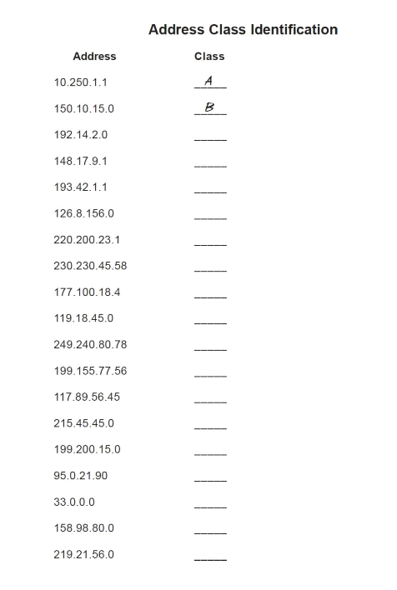

C

B

A

A

C

C

A

C

E

A

B

D

C

A

C

B

C

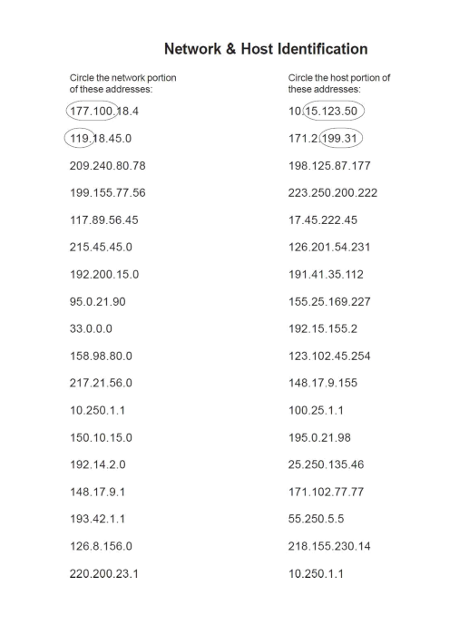

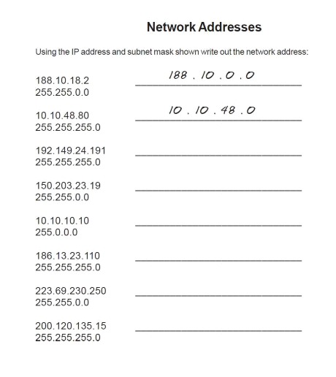

200.120.135.0

223.69.0.0

186.13.23.0

10.0.0.0

150.203.0.0

192.149.24

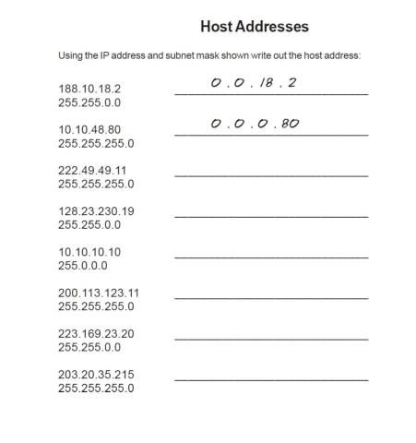

0.0.0.215

0.0.23.20

0.0.0.11

0.10.10.10

0.0.230.19

0.0.0.11

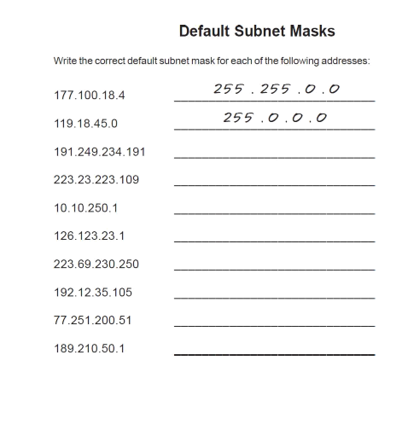

255.255.0.0

255.0.0.0

255.255.255.0

255.255.255.0

255.0.0.0

255.0.0.0

255.255.255.0

255.255.0.0

**Q1**

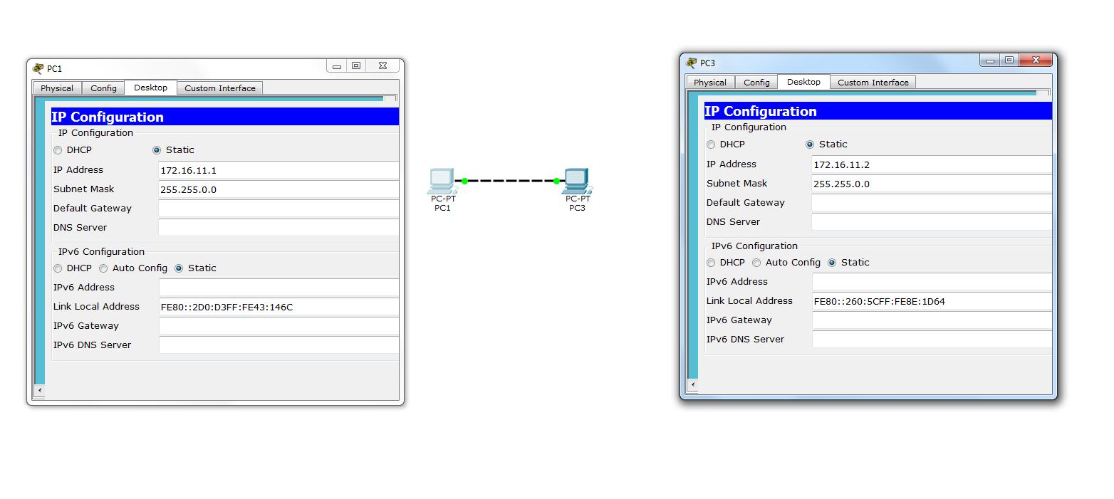

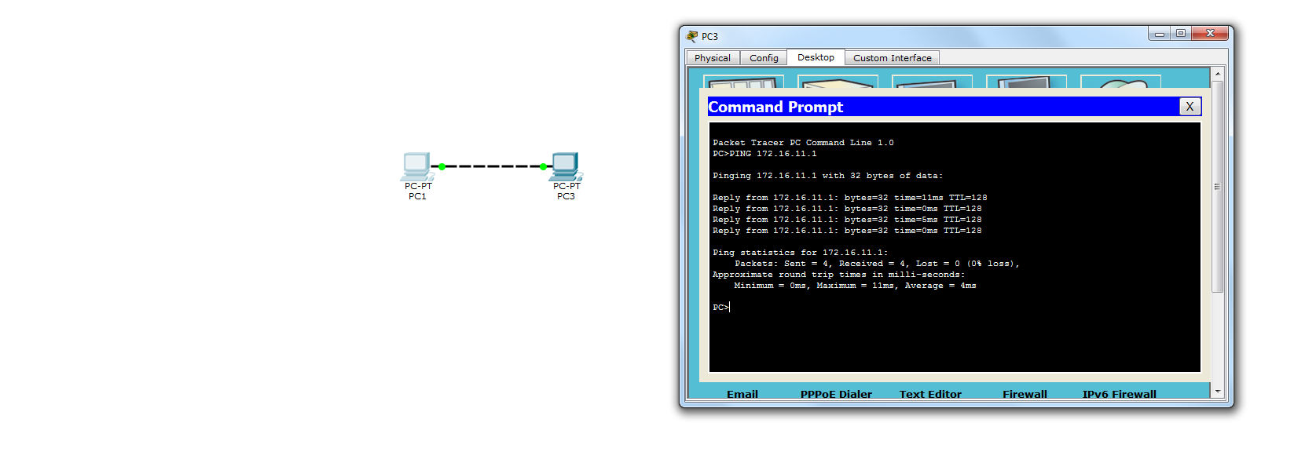

**As the two PCs are similar devices hence a cross wire is used.**

**Q2**

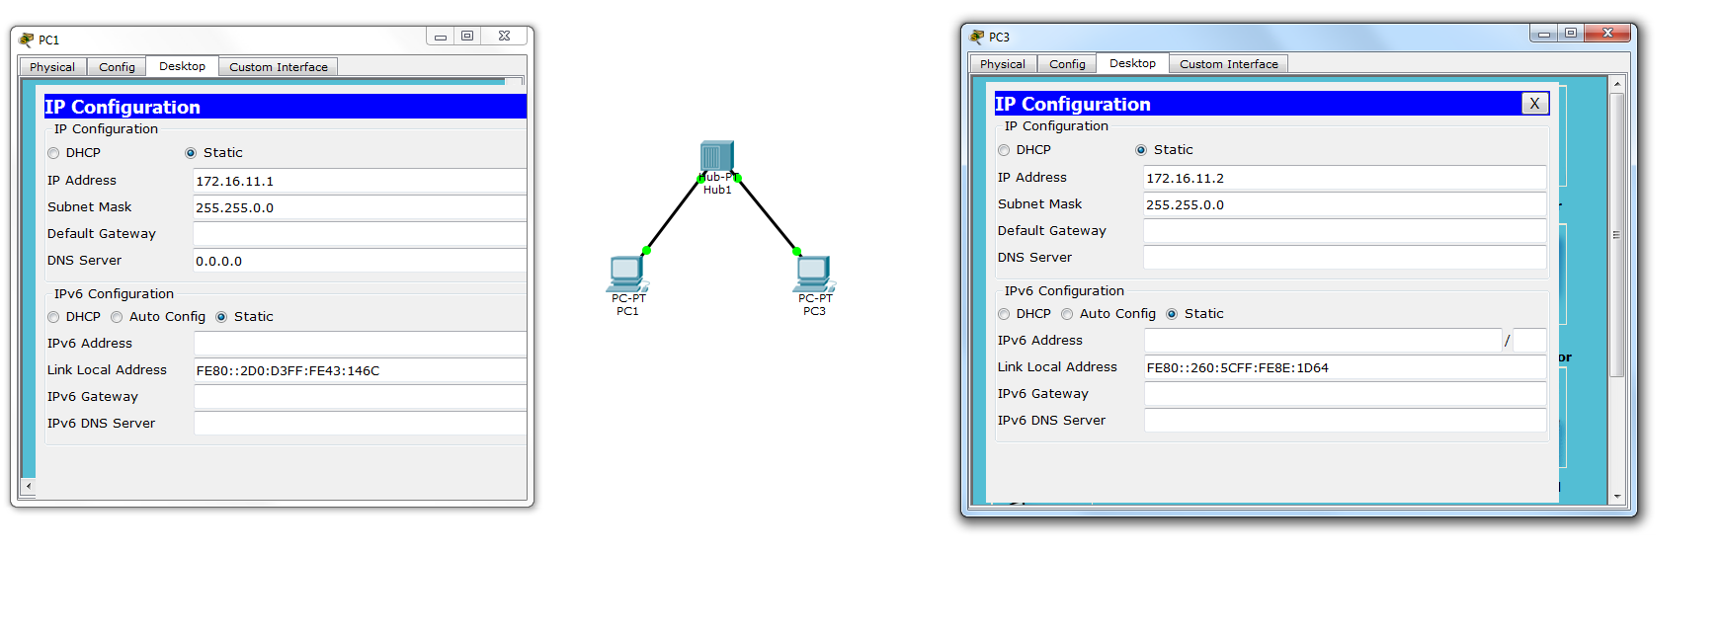

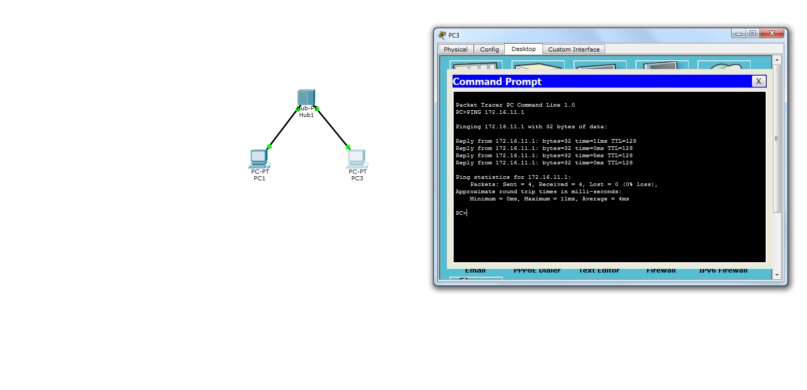A hub is a common connection point for the two PCs in this network. It is connecting the two segments of the LAN.

Q3

1. Straight wire: linking two different devices i.e PC and switch.
2. Straight wire: linking two different devices i.e router and switch.
3. Cross wire: linking two similar devices i.e router and router.

Q4

In real-time mode the network behaves as real devices do, with immediate real-time response

for all network activities. In logical mode, the user can see and control the the data transfer in the network over the time interval.